

**ONLINE FOOD ORDERING SYSTEM**

For the Evaluation of

# Project Mode – CS23333 OBJECT ORIENTED PROGRAMMING

**LANGUAGE USING JAVA**

***Submitted by***

**JOSHIKA S(231001078)**

**MONASREE R(231001115)**

**MINI PROJECT REPORT**

**November 22, 2024**

# DEPARTMENT OF INFORMATION TECHNOLOGY

**RAJALAKSMI ENGINEERING COLLEGE,THANDALAM**

**BONAFIDE CERTIFICATE**

This is to certify that this project report titled “**ONLINE FOOD ORDERING SYSTEM”** is the bonafide work of **JOSHIKA S(231001078) , MONASREE R(231001115)** who carried out the work under my supervision. Certified further that to the best of my knowledge the work reported herein does not form part of any other thesis or dissertation on the basis of which a degree or award was conferred on an earlier occasion on this or any other candidate.

|  |  |
| --- | --- |
| **SUPERVISOR** | **Head/IT** |
| **Mrs.S.Padmini** | **Dr.Valarmathi** |

## Date : 22.11.2024

**ABSTRACT**

The Online Food Ordering System is an innovative web-based application designed to provide users with an easy, efficient, and seamless platform for ordering food from restaurants. The system integrates a **Database Management System (DBMS)** and **Java Database Connectivity (JDBC)** to offer robust and dynamic data management.

The core objective of the system is to facilitate the interaction between customers, restaurants, and administrators through an online interface. Customers can browse restaurant menus, place orders, and make payments while administrators can manage the restaurant's offerings, track orders, and analyze customer data. The system uses a **relational database** (such as MySQL or PostgreSQL) to store user, order, and restaurant information, ensuring data integrity, security, and efficient access.

The **DBMS** plays a crucial role in ensuring that all data (customer details, orders, and restaurant menus) is organized, stored, and retrieved efficiently. The JDBC interface connects the Java- based frontend to the backend database, enabling seamless interaction between the two layers. Through JDBC, queries are sent to the database for operations like retrieving restaurant menus, placing orders, updating customer details, and processing payments.

The system ensures high performance and reliability through structured query language (SQL) for efficient data retrieval and modification. Additionally, it includes features such as real-time order tracking, customer feedback, and personalized recommendations, which enhance the user experience. This food ordering system provides the foundation for a scalable and secure solution for the growing online food delivery industry.

In conclusion, the Online Food Ordering System with DBMS and JDBC presents a comprehensive solution that leverages modern technologies to simplify food ordering and management processes, benefiting both customers and businesses.

**TABLE OF CONTENTS**

|  |  |  |
| --- | --- | --- |
| **CHAPTER NO** | **TITLE** | **PAGE NO** |
|  | **ABSTRACT** | 3 |
|  | **LIST OF TABLES** | 5 |
|  | **LIST OF FIGURES** | 5 |
|  | **LIST OF ABBREVIATIONS** | 5 |
| **1** | **INTRODUCTION** | 6 |
| **1.1 Motivation** | 6 |
| **1.2 Existing System** | 6 |
| **1.3 Project Objectives** | 7 |
| **1.4 Proposed System** | 7 |
| **2** | **SYSTEM DESIGN** | 8 |
| **3.1 Introduction** | 8 |
| **3.2 System Architecture** | 8 |
| **3.3 System Requirements** | 9 |
| **3** | **PROJECT DESCRIPTION** | 10 |
|  | **3.1 Methodologies** | 10 |
|  | **3.2 Module Description** | 10 |
| **4** | **Results** | 11 |
| 43 | **Output Images** | 12 |
|  | **CONCLUSION** | 13 |

**LIST OF TABLES**

|  |  |
| --- | --- |
| TABLE | **PAGE NUMBER** |
| Table 3.1 | 10 |

**LIST OF FIGURES**

|  |  |
| --- | --- |
| **TABLE** | **PAGE NUMBER** |
| Fig 4.1 | 11 |
| Fig 4.2 | 12 |
| Fig 4.3 | 12 |

**CHAPTER - 1**

**INTRODUCTION**

### 1.1 MOTIVATION

1. The increasing demand for convenience and efficiency in daily life has led to significant advancements in various sectors, particularly the food service industry. The emergence of online food ordering platforms is a direct response to changing consumer behavior and the growing need for on-demand services. Consumers are looking for faster, more convenient ways to order food without the hassle of traditional phone orders or in-person visits. This trend is further fueled by advancements in mobile technology and the widespread availability of internet access.
2. **1. Consumer Convenience:** The motivation behind creating an Online Food Ordering System is to meet the evolving needs of consumers who prefer to place orders from the comfort of their homes or offices. A streamlined online platform allows users to browse restaurant menus, make personalized orders, and pay for food with ease. Additionally, features such as order tracking, real-time delivery status updates, and reviews make the food ordering experience much more convenient and transparent.
3. **2. Efficiency for Restaurants:** For restaurants, managing orders, updating menus, processing payments, and tracking inventory manually can be cumbersome and prone to error. The implementation of a Database Management System (DBMS) in the backend ensures that restaurants can efficiently manage large amounts of data, from customer orders to financial transactions. Using **JDBC** to connect the front-end application to the database provides a reliable and scalable solution to perform operations like storing customer data, processing payments, and updating menu items without system overloads or data inconsistencies.

**4.1 EXISTING SYSTEM**

**Features and Characteristics of Existing Systems:**

* + **Real-time Updates:** The use of DBMS allows these systems to provide up-to-date information on orders, restaurant availability, and delivery statuses.
  + **Scalability:** The database systems are designed to handle large volumes of data and scale with growing user demands, especially for platforms like Uber Eats, Zomato, and Swiggy, where millions of users place orders daily.
  + **Transaction Management:** DBMS helps in managing financial transactions, ensuring accuracy in payment processing and order management.
  + **Security:** Sensitive customer data, including payment details and personal information, are stored securely in databases. These systems employ encryption and other security measures to safeguard user information.

### 4.2 PROJECT OBJECTIVES

The **Online Food Ordering System** using **DBMS** and **JDBC** aims to create a platform where users can easily order food from restaurants, with a backend infrastructure that ensures efficient data management, real-time updates, and secure transaction processing. Below are the key project objectives:

1. ***User-Friendly Interface for Customers***

* + **Objective:** To design a simple and intuitive user interface where customers can browse restaurant menus, select food items, customize their orders, and place food orders effortlessly.
  + **Goal:** Enhance user experience through a clear, responsive, and easy-to-navigate platform (web or mobile).

1. ***Efficient Database Management for Data Handling***

* + **Objective:** To implement a **Database Management System (DBMS)** that ensures efficient storage, retrieval, and manipulation of data, including customer details, restaurant menus, orders, and payment transactions.
  + **Goal:** Use a **relational database** (e.g., MySQL or PostgreSQL) to maintain structured and consistent data while ensuring data integrity, security, and backup procedures.

1. ***Real-Time Order Processing and Updates***

* + **Objective:** To enable real-time updates for order processing, allowing customers to track their orders from placement to delivery.
  + **Goal:** Ensure that orders are processed efficiently and that users receive real-time feedback, including order status updates (e.g., "Order Confirmed," "In Preparation," "Out for Delivery").

1. ***Integration of JDBC for Database Connectivity***

* + **Objective:** To establish seamless interaction between the front-end (user interface) and back-end (database) using **Java Database Connectivity (JDBC)** for smooth data transfer.
  + **Goal:** Ensure secure and efficient connection for operations like order placement, payment processing, and updates to the restaurant menu or customer records.

### 4.3 PROPOSED SYSTEM

The **Proposed Online Food Ordering System** aims to provide a seamless, user-friendly platform that connects customers with restaurants through a web or mobile application. This system will allow customers to browse restaurant menus, customize their orders, and place food orders easily. Real-time order tracking will provide customers with updates on the status of their orders, including order confirmation, preparation, and delivery. The system will integrate a **Database Management System (DBMS)** to efficiently store and manage customer details, orders, restaurant menus, and transaction data. **Java Database Connectivity (JDBC)** will be used to connect the front-end application with the back-end database, ensuring smooth communication between the user interface and the data layer.

**BENEFITS OF THE PROPOSED SYSTEM**

The **Proposed Online Food Ordering System** offers numerous benefits to customers, restaurants, and administrators, all while improving efficiency, data security, and user experience. Below are the key advantages of implementing this system:

1. **Enhanced Customer Convenience**

* + **Benefit:** Customers can place food orders from anywhere, anytime, without needing to visit a restaurant physically or place orders over the phone.

1. **Real-Time Order Tracking**

* + **Benefit:** Customers can receive real-time updates on their orders, such as order confirmation, preparation, and delivery status.

1. **Improved Restaurant Management**

* + **Benefit:** Restaurants can easily manage their menu items, update prices, and track orders with the admin interface.

1. **Efficient Data Handling with DBMS**

* + **Benefit:** The use of a **Database Management System (DBMS)** ensures that all customer information, orders, and restaurant data are securely stored and efficiently managed.
  + **Impact:** This leads to better data organization, faster data retrieval, and improved overall performance. The DBMS can handle large volumes of transactional data, ensuring smooth operations even during peak times.

**CHAPTER – 2**

**SYSTEM DESIGN**

## 2.1 INTRODUCTION

The **System Design** of the **Online Food Ordering System** using **Database Management System (DBMS)** and **Java Database Connectivity (JDBC)** focuses on creating an efficient and scalable solution for both customers and restaurants. This system aims to facilitate seamless communication between users, restaurants, and the underlying database. The design encompasses both the **front-end** (user interface) and the **back-end** (database and server) components, ensuring a smooth flow of data, secure transactions, and real-time order processing. The system ensures real-time updates for order status, enabling customers to track their food from placement to delivery. To maintain security, sensitive data such as payment information is encrypted, and strict authentication and authorization mechanisms are implemented. The system is designed for scalability, ensuring it can handle growing user numbers and peak usage times without compromising performance.

## 2.2 SYSTEM ARCHITECTURE

The system architecture is based on a three-tier design include Presentation Layer, Application Layer, and Data Layer.

### 1. Presentation Layer (Front-End)

The **Presentation Layer** of the **Online Food Ordering System** serves as the user interface, allowing customers and restaurant administrators to interact with the system. It enables customers to browse menus, place and customize orders, track their order status, and make secure payments. The layer is built using web technologies like **HTML5**, **CSS3**, and **JavaScript** for web platforms, and **Android Studio** and **Xcode** for mobile apps. It communicates with the backend via **API calls** or **JDBC** to process orders and transactions. The presentation layer also includes security features like user authentication and payment encryption, ensuring a smooth and secure user experience across all devices.

### 2. Application Layer (Logic/Controller Layer)

The **Application Layer** in the **Online Food Ordering System** serves as the intermediary between the **Presentation Layer** (user interface) and the **Database Layer** (DBMS). It handles the core business logic and application functionality, processing user requests, validating data, and ensuring that operations are performed correctly.

In this system, the application layer performs key tasks such as:

1. **Order Processing:** The application layer receives orders from the presentation layer, validates them, and processes them (e.g., checking the availability of menu items, calculating prices, and storing order details in the database).

### 3. Data Layer (Back-End)

The **Data Layer** in the **Online Food Ordering System** is responsible for managing and storing all the data required by the system. This layer interacts directly with the **Database Management System (DBMS)** to handle the creation, retrieval, updating, and deletion of data. It acts as the foundation for storing information such as customer details, orders, menus, payments, and reviews.

Key responsibilities of the **Data Layer** include:

1. **Storing Customer Information:** It manages customer data, such as personal details (name, contact info, address), order history, and preferences. This data is securely stored in the database and can be accessed when customers log in or place new orders.
2. **Order Management:** The data layer handles the storage of orders placed by customers. This includes details like the food items ordered, quantities, total price, payment status, and order timestamps. The system also tracks the order’s status (e.g., pending, preparing, delivered) as it moves through the restaurant’s workflow.

#### 2.3 SYSTEM REQUIREMENTS

**HARDWARE SPECIFICATIONS:**

PROCESSOR : Intel i5

MEMORY SIZE : 4GB(Minimum)

HARD DISK : 500 GB of free space

**SOFTWARE SPECIFICATIONS:**

PROGRAMMING LANGUAGE : Java, MySQL

FRONT-END : Java

BACK-END : MySQL

OPERATING SYSTEM : Windows 10

**CHAPTER - 3**

**PROJECT DESCRIPTION**

## 3.1 METHODOLOGIES

**PRESENTATION**

**(**

**FRONTEND**

**)**

**LAYER**

JavaFX

(

GUI

:

Forms,Charts)

**APPLICATION**

**(**

**)**

**BACKEND**

**LAYER**

JAVA

and

JDBC

Connectivity

**DATA(DBMS)LAYER**

MYSQL(Tables,Views)

***Table***

***3.1***

# 3.2 MODULE DESCRIPTION

**.** DASHBOARD PAGE

**.** CRIME RECORD PAGE

**.** INCIDENT REPORTS PAGE

## CHAPTER – 4 RESULTS Output Images

**4.1 ER DIAG:**

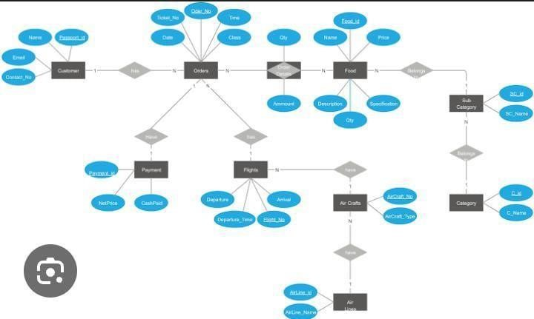

**4.2 Incident Reports Page**

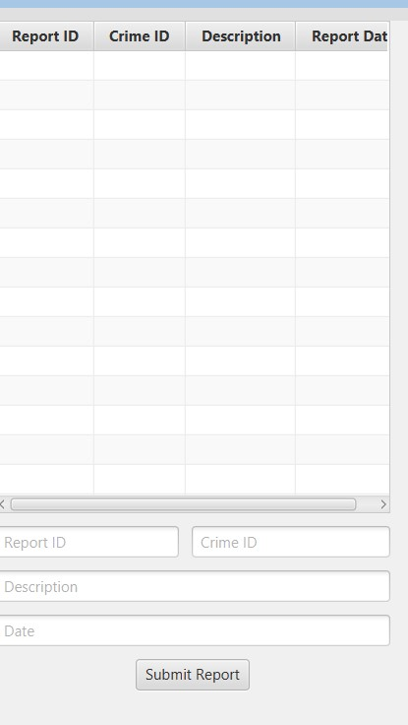

### *Fig 4.3*

**CONCLUSION**

In conclusion, the **Online Food Ordering System** using **DBMS** and **JDBC** provides an efficient, secure, and scalable solution for both customers and restaurants. By leveraging a well-structured system design that includes the **Presentation Layer**, **Application Layer**, and **Data Layer**, the system ensures a seamless user experience for ordering food, making payments, and tracking orders in real-time. The **DBMS** ensures secure and consistent management of data, while **JDBC** facilitates smooth communication between the front-end and database. This architecture not only meets the current needs of food ordering but is also flexible enough to accommodate future growth and technological advancements. By incorporating user-friendly features, robust backend processing, and secure payment systems, the proposed system promises to enhance the efficiency of online food services and provide customers with a reliable and enjoyable ordering experience. Ultimately, this system improves operational efficiency for restaurants while offering convenience and satisfaction to customers.